**Steps To Complete GitHub Coding Projects/Assignments with Screen Shots**

Step-1:- Visit Google and login In to mail Id of your GitHub Account

*Note: Your Google Login should be same to GitHub account Mail-ID*

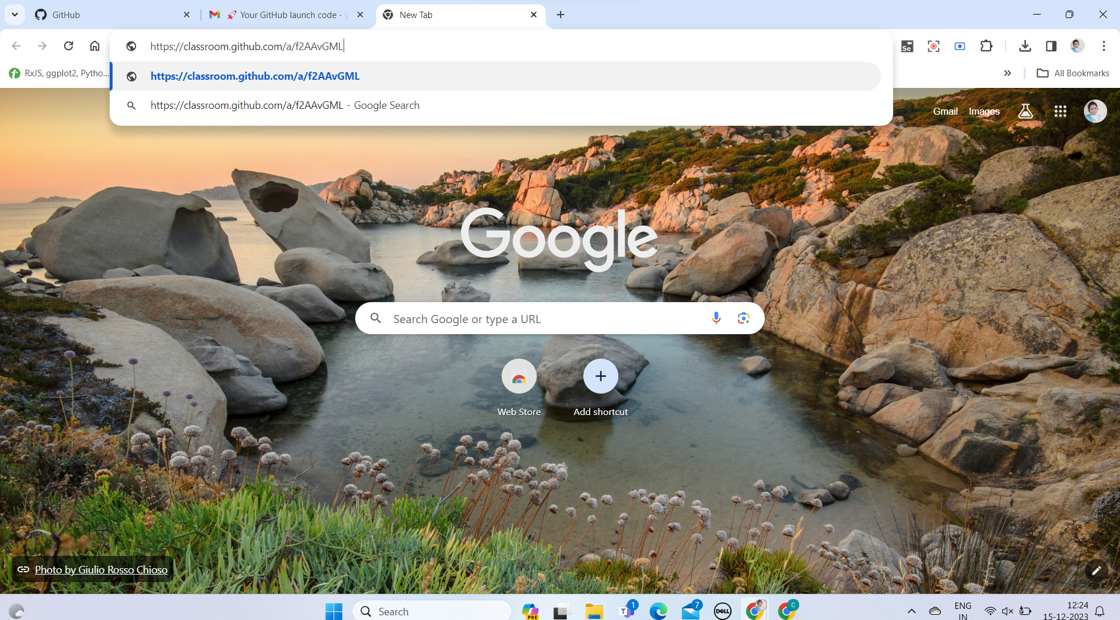

Once you Enter the link and browse you will be navigated to GitHub Classroom Portal / It Could Ask for Login to GitHub Classroom - Please Do Login and Authorize Permission.

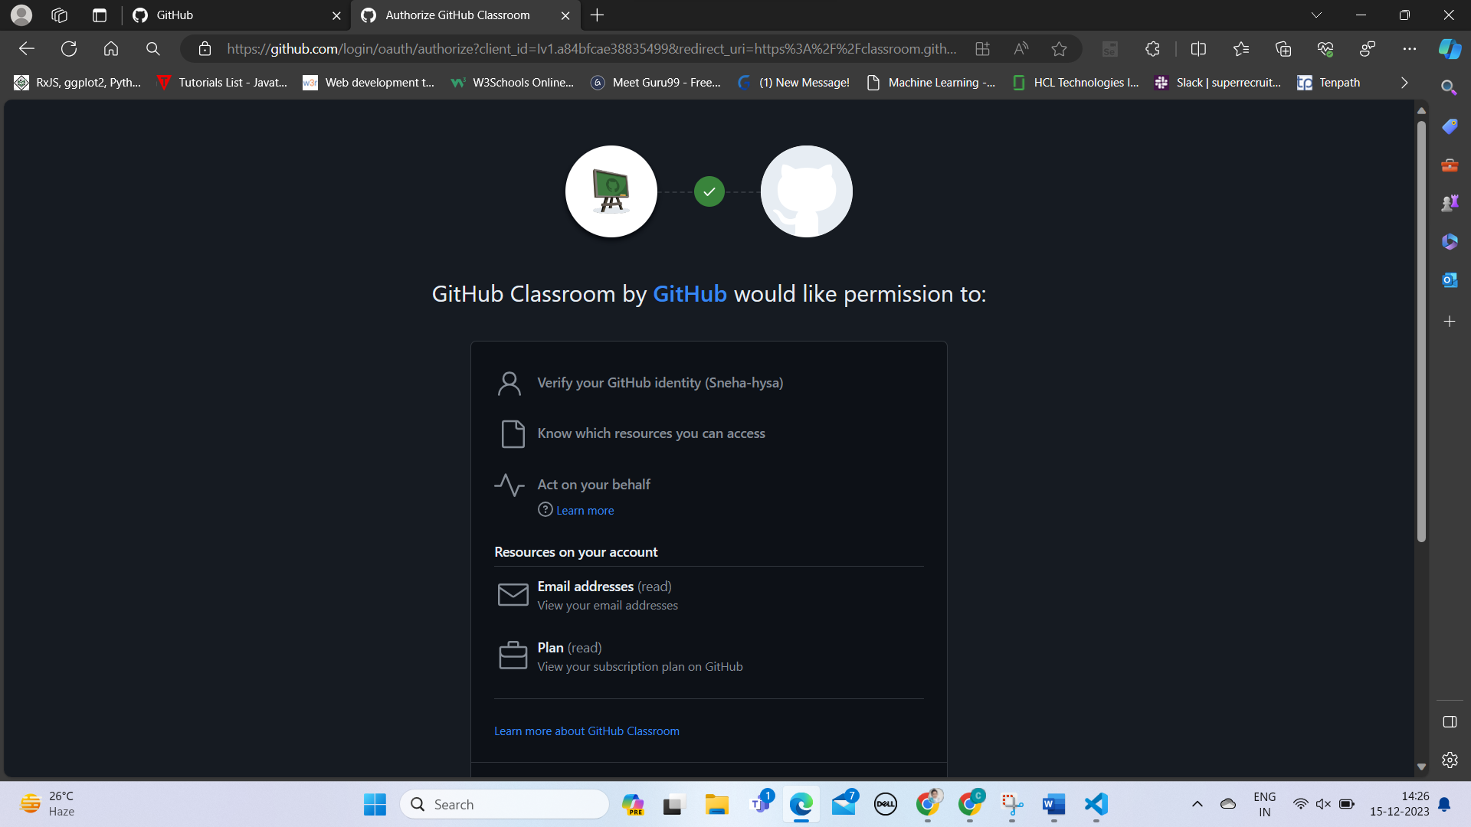

Step-2 : Join Your GitHub Classroom

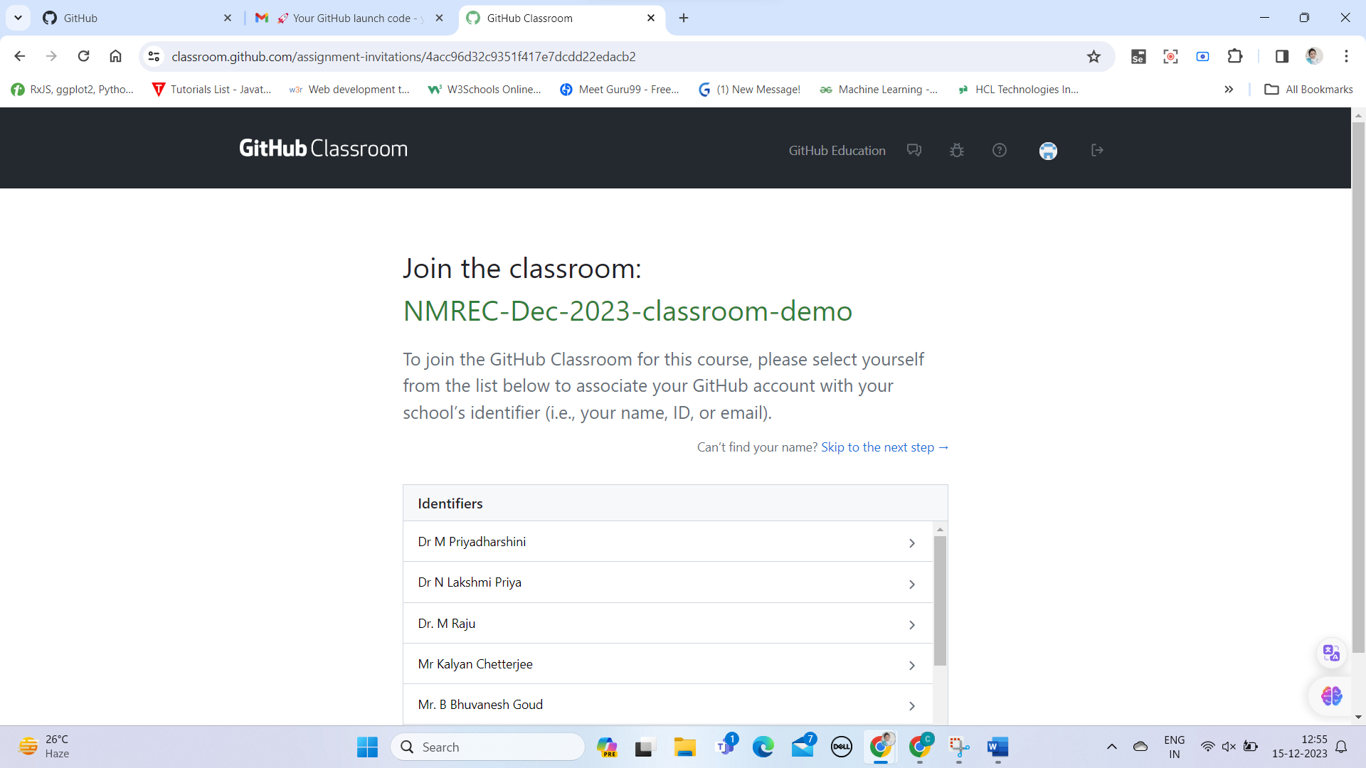

Once You Select Your Name a Dialogue Box Appears to confirm your Identity. Please click ok.

Step-3:- Accept the Assignment

*If you are not login to your GitHub Account It might ask for Login. Please do login.*

Please do click on Accept the Assignment Button

Step-4:- GitHub Repository for Assignment Will be Created in Your GitHub Account

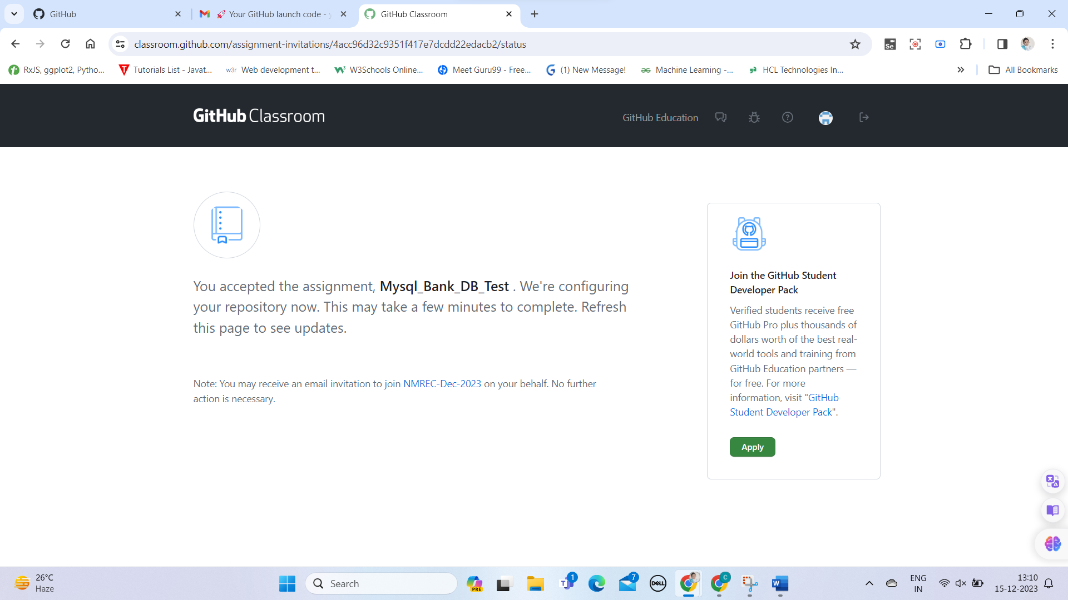

Reload the Page to View the Assignment Repository.

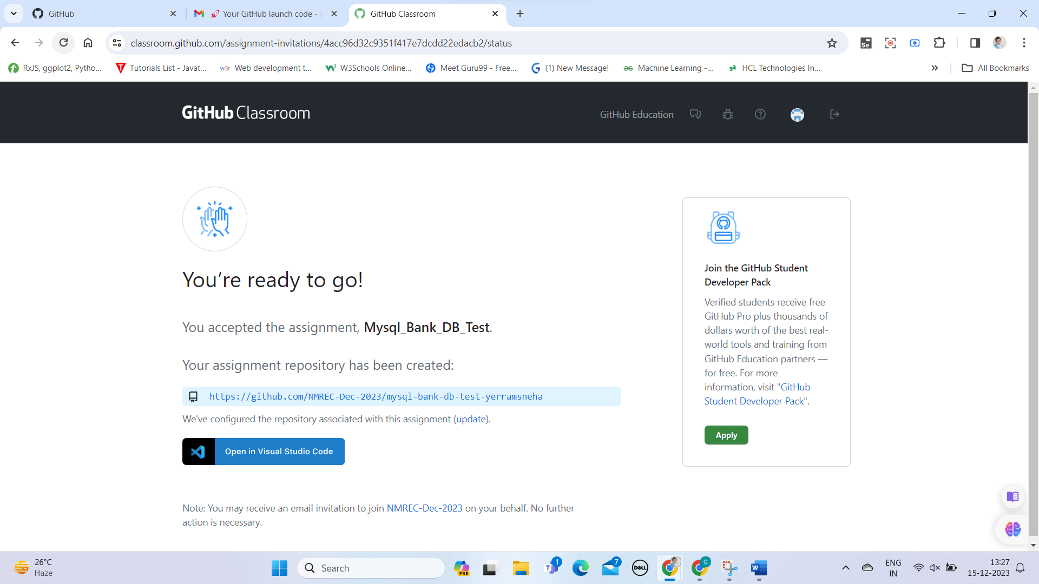

You can See a GitHub Link and a supported IDE to Complete your Code.

Once you Click on link it will navigate to GitHub Repository in Your Account.

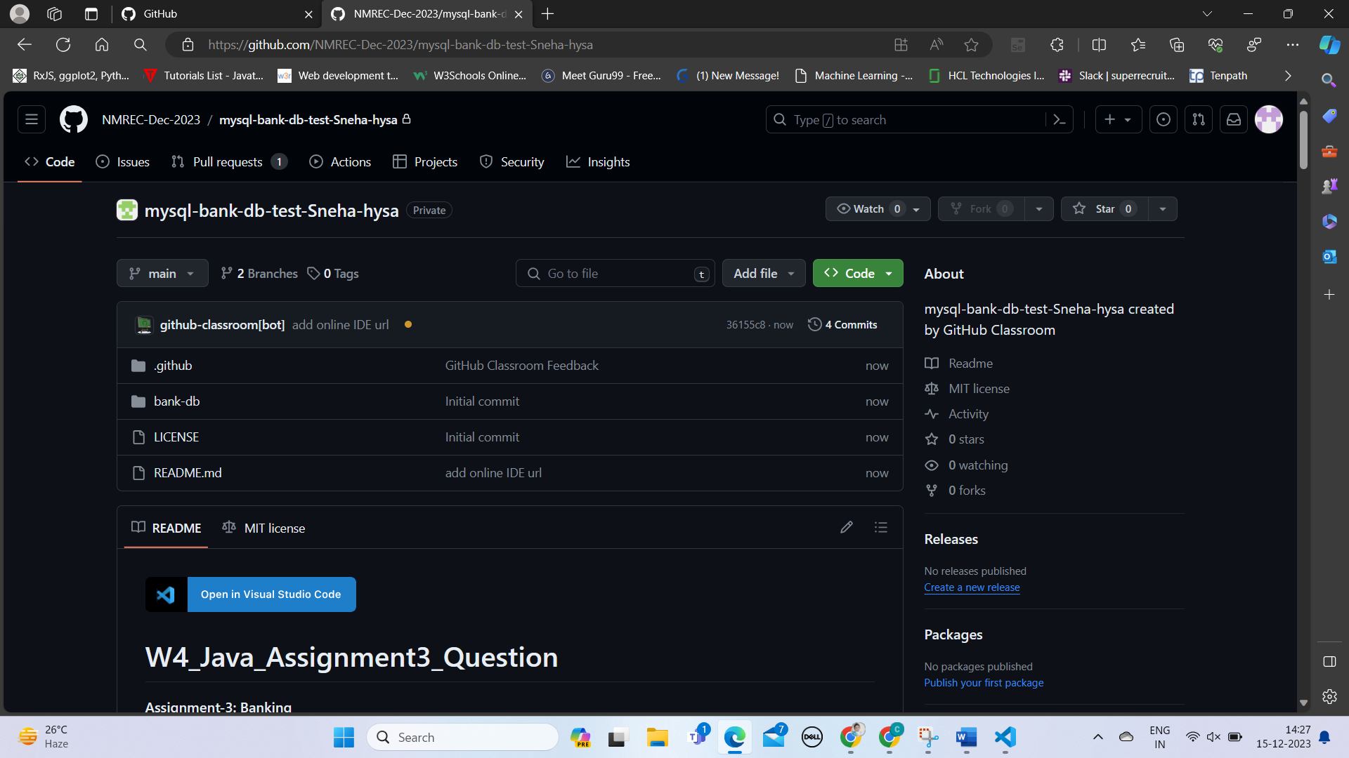

Step 5 :- Submit Your Code

Go through Read me File to Submit your Solution, in this demo we have navigated to following Java File.

bank-db/src/main/java/com/example/BankDatabase.java

Once You Navigate to the File Please do complete the Code

After Completing the Code Click on Commit Changes Button on the Right Top.

Insert a Commit Message.

After Committing Changes, Please Navigate to Your Repository.

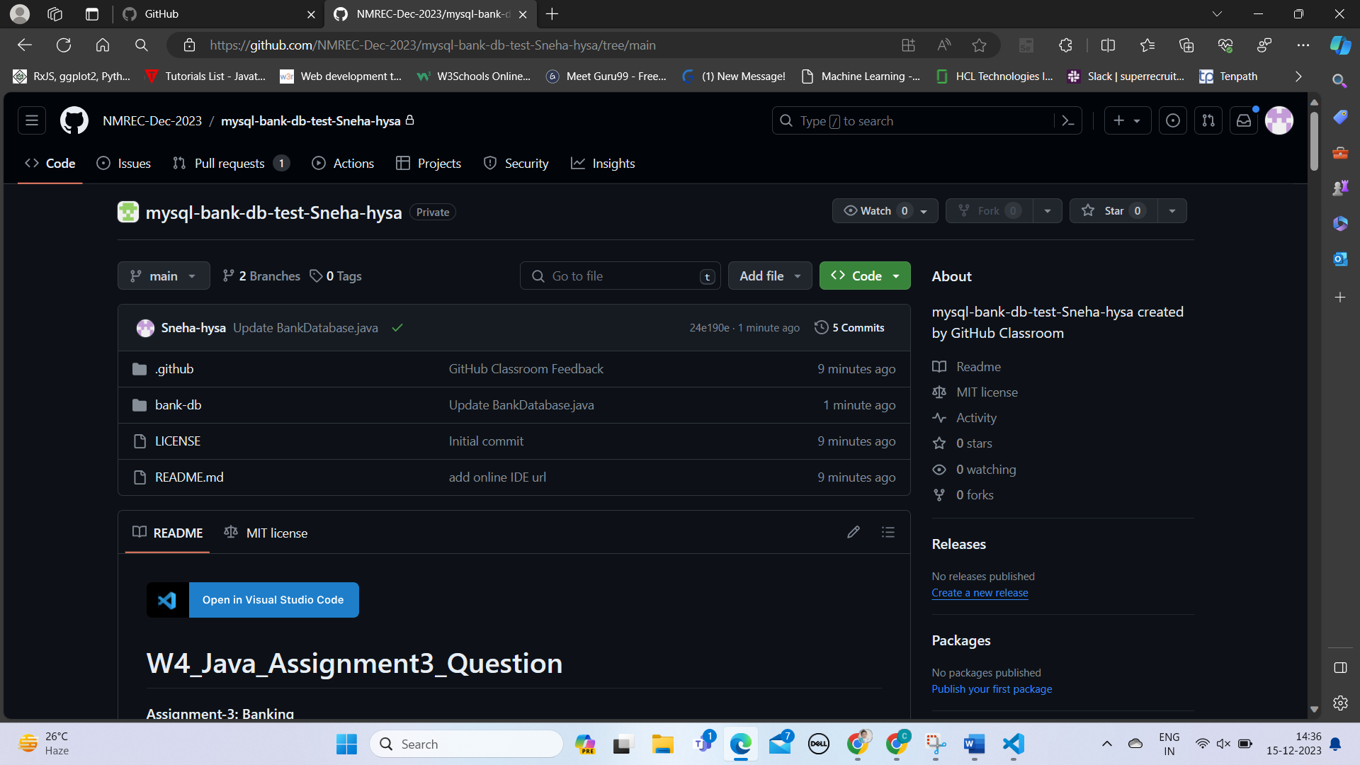

Below Main You can See Your GitHub Username and beside it you can see the green coloured right mark, Which means You have a Successful Commit and **Congratulations!!!** on Completing Your Project Successfully.

If You are not Able to Complete a successful Commit, Please do revise you Code Without Errors.